I B. Tech II Semester Supplementary Examinations – June, 2024
PROBLEM SOLVING THROUGH PROGRAMMING - II
(BIOTECH/BI)
Time: 150 Min Max. Marks:60M
SECTION – A
Answer all Four questions 4×8M=32M

- List the arithmetic operations that are allowed on pointers. What we mean by generic pointers? Can we perform the arithmetic operations on generic pointers? If not, why?
- Consider a 1-dimensional array of characters char str[] =” I came by walk”. Develop code snippets that perform the following.
- Display the string contained in str using pointer notations. Do not simply print the string using printf() function.
- Find the length of the string using pointer notations. Do not use any library function to find the length of the string.
- Using pointer notations develop a code snippet to perform the following.
- Given a string s and a dictionary of strings wordDict, develop a function to return true if s can be segmented into a space-separated sequence of one or more dictionary words.
Note that the same word in the dictionary may be reused multiple times in the segmentation.
For example,
Input: s = "applepenapple", wordDict = ["apple","pen"]
Output: true
Note: Return true because "applepenapple" can be segmented as "apple pen apple".

- When do we array of structures? Illustrate array of structures with a suitable example.
- Consider the following.
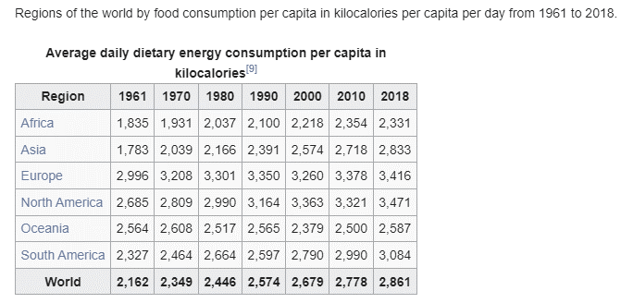
Create appropriate structure members to store the above data and develop a program that prints the data as given in the above table.

- Given the above table, develop a program to do the following.
- Find the highest energy consumption year for a specific region among the many years of data of that region.
- Which region’s energy consumption is the closest to the world energy consumption for the year 1961?
- Which region’s energy consumption data is the closest to the Asia region?

- What is the purpose of getw() and putw() functions? Write their syntax.
- Develop code snippets that do the following.
- Write a list of random integer values into a file called “numbers.dat”.
- Read and print all the integers from the file “numbers.dat” such that the numbers are printed in ascending order.
- Assuming a file called “numbers.dat” that contains a list of integers already exists; develop a code snippet that reads integers from the file and prints all the prime integers in the descending order first, followed by all the non-prime (composite) numbers in ascending order.

- Why do we need dynamic memory allocation? List all the library functions related to dynamic memory allocation along with their syntax.
- Create a matrix of integers of order m x n dynamically using array of pointers and develop code snippets to perform the following.
- Fill the matrix with all odd numbers starting from 1.
- Replace all the prime numbers in the matrix with even numbers starting from 0.
- Continuing with the matrix created in the problem 4 (b) (i), develop a code snippet to perform the following
- Find the row sums that exclude the prime numbers.
- Find the count of prime numbers in every column.

SECTION - B
Answer all Two questions 2×14M=28M

- List all the differences between arrays and structures? Illustrate with suitable examples.
- Consider an array of integers nums = [31, 51, 27, 89, 66, 23, 13, 57]. Develop a code snippet to arrange the elements of the array nums in descending order using pointer notations.
- Continuing with the array nums = [31, 51, 27, 89, 66, 23, 13, 57], develop a code snippet that deletes all the prime numbers from the array and displays the array such that the array nums appears as nums=[27,51,57,66].
- Consider the array of integers nums = [31, 51, 27, 89, 66, 23, 13, 57] given in 4 (b), develop a code snippet to arrange the numbers based on the number of divisors, such that the number having the least number of divisors appears first in the list and the number having the highest number of divisors appears last in the list; if the numbers have same number of divisors, then they must listed based on their numeric order.

- Why do you think that, the structures provide better representation of data, when multiple data items of different data types having a similar purpose exist? Explain with suitable example.
- Create a structure called Employee and include the following members.
- idno – identity number of an employee which is a string
- name – the name of an employee which is a string
- salary – the salary of the employee, float value
Create an array of structures of type Employee and store the details of a given list of the employees. Develop a program to arrange the employee records in the descending order of the salaries.
- Extend the Employee structure to include the following members.
- dob – the data of birth of the employee, which is of the date type which again is structure type described as follows.
struct date
{
int day;
int month;
int year;
};
- coming_from – a string that indicates where the employee is currently staying
Create an array of structures of type employee and input the details of all the employees. Develop a menu driven program that does the following.
- Order the employee records based on their data of birth, the oldest employee on the top of the list.
- List all the employees coming from a particular place, for example, “GUNTUR”.
- Extend the structure Employee further to add the following members.
- doj – the date of joining the company, which is of type date
- dept_name – the name of the department, which is a string
that can be one of the following, “Production”, “Admin”, Sales”, “HR”, “Inventory”.
Create a structure of the extended employee type and write a given list employee records into a file called “employee.dat”. Develop a menu driven program to do the following.
- Find the total salary paid to the employees of a particular department.
- Given an employee id number, display the details of the employee.
- List all the employees of a particular department.
- List all employees due for retirement on a specific month. Assume the retirement age as 60 years.

